Updating Printers in Windows 10
wviands July 8th 2021

Since a major network change in January of 2021 you’ll find that your printers are no longer available. They really are but they now have different IPs. This is to help you update the Printers you have in your computer with the new IPs.

In the bottom left of the taskbar is a white search box, just type in printers and hit enter.
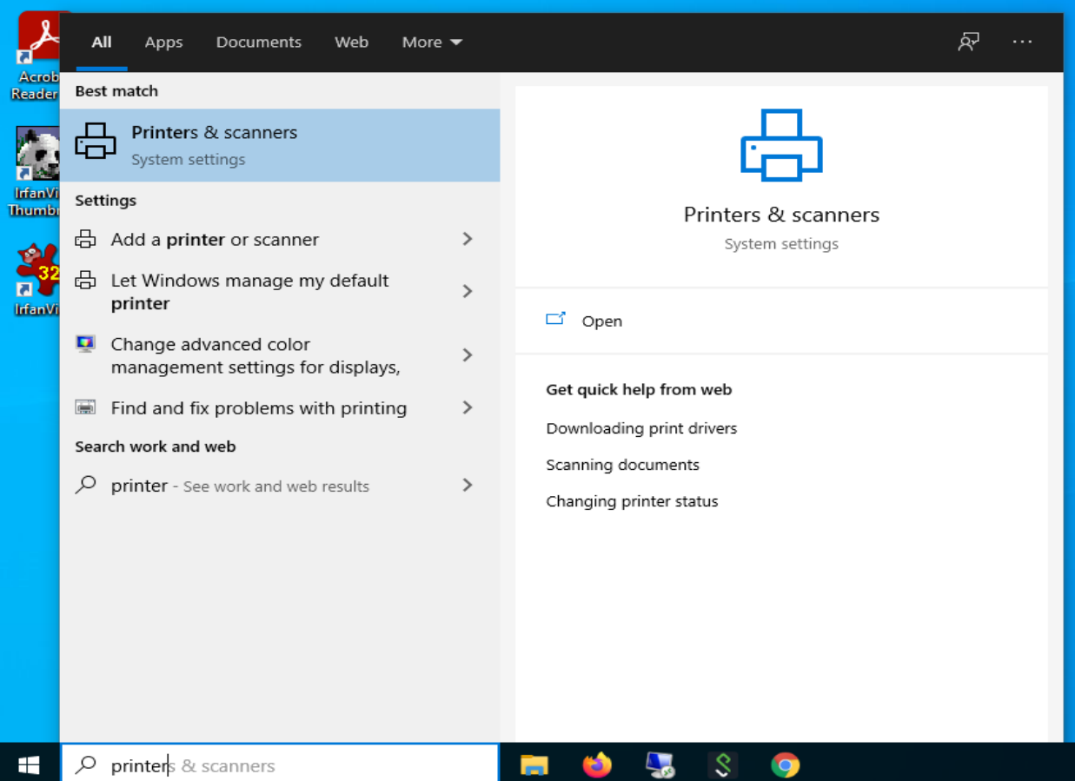
In the above image you can see I didn’t even finish the word and what I want is there so I hit enter and the image on the next page opens.

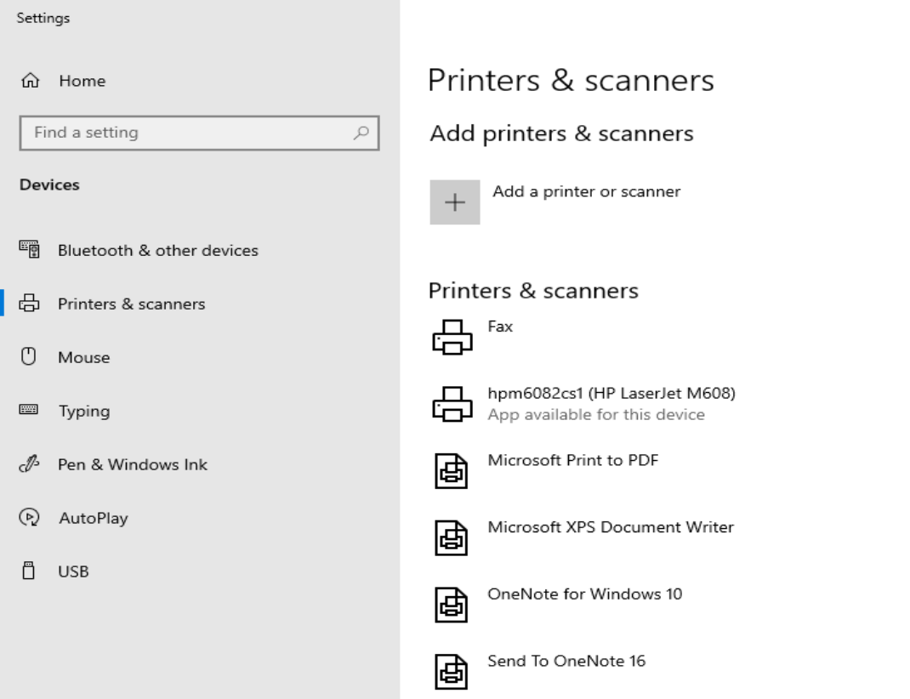
Now keep in mind that everyone's printers will be different. As long as you see something that looks a lot like the above image then you’re good. I’ve only got one printer on this workstation but that’s all we need to show you what to do.

Click on the printer you want to update. It opens a window like below…
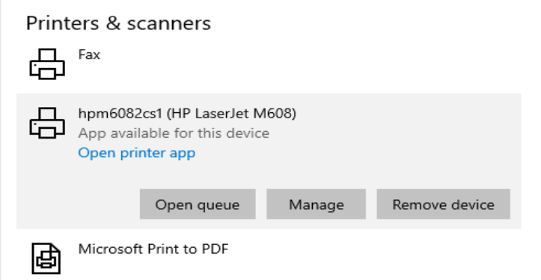

We’re going to click on “Manage” which brings up another window.
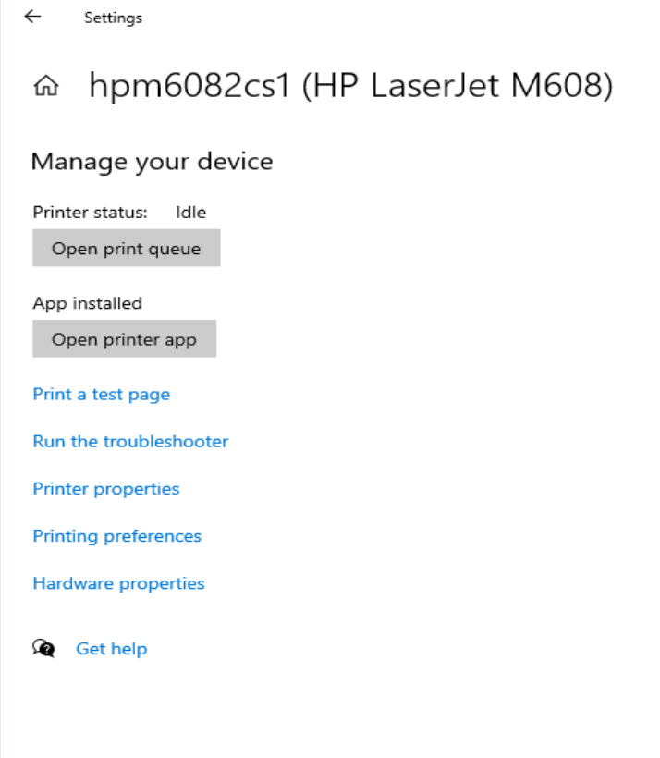

In this window we’re going to click on “Printer properties” so we can finally get something done. It actually opens to the correct page right off the bat.

See the “Location” part in the image on the next page? I’ve highlighted it to make it easier to see.

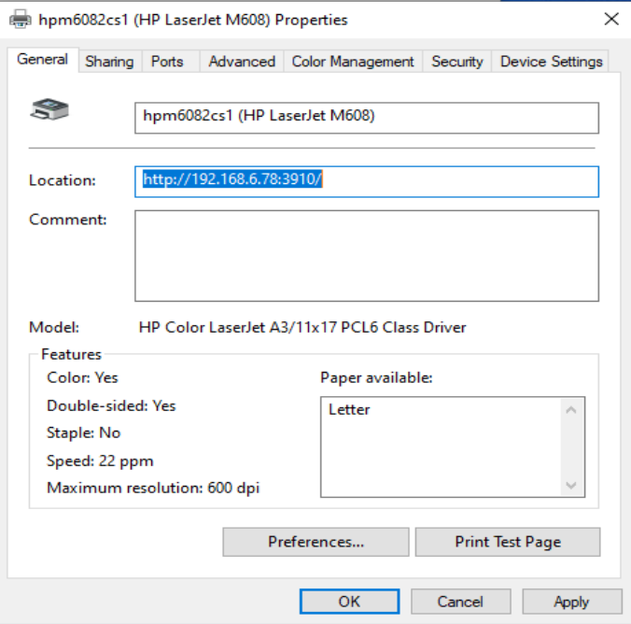

That’s the part we’re going to change. We do NOT want 192.168.6.78 in there. You’re numbers will be different but they’ll start with 192.168 and the number we want to change to will start with 10.166.

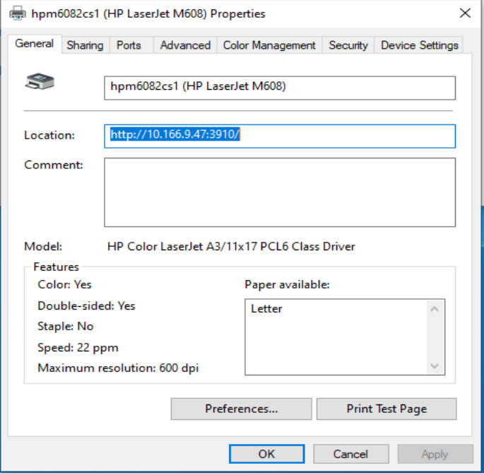
In the image below I’ve made the change and highlighted the entire line.

Click “OK” and go to the next printer until you got them all. You shouldn’t need drivers or anything else, just change the IP (the number).

At this point you’re probably thinking, “Well that’s nice but where do we get the new IP?” Good question. I was going to put a list of them in this document but as I’m writing it I realize it will be a lot easier if I put the IP on the printers in the office. This way you can just walk up to the printer you want, read its name and IP then do all the above things you read about earlier.

Please keep in mind that while it might be nice to add a printer you never had access to before that it might not work if you don’t have drivers already installed. So don’t bother putting in a help desk ticket.

