Windows 7 Printer Update
wviands July 8th 2021

Since a major network change in January of 2021 you’ll find that your printers are no longer available. They really are but they now have different IPs. This is to help you update the Printers you have in your computer with the new IPs.

Click on the round thing in the bottom left side of your screen. It’s a Microsoft logo. In the window that opens there will be a search box, type in ‘printer’ like I did and then hit enter.
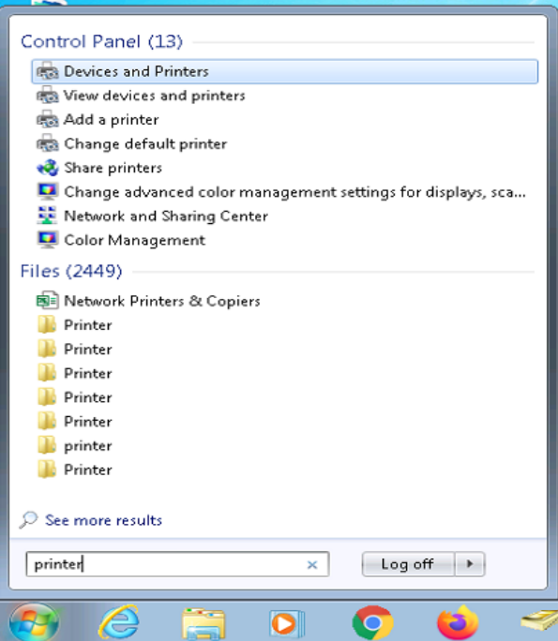

That opens the window on the next page...

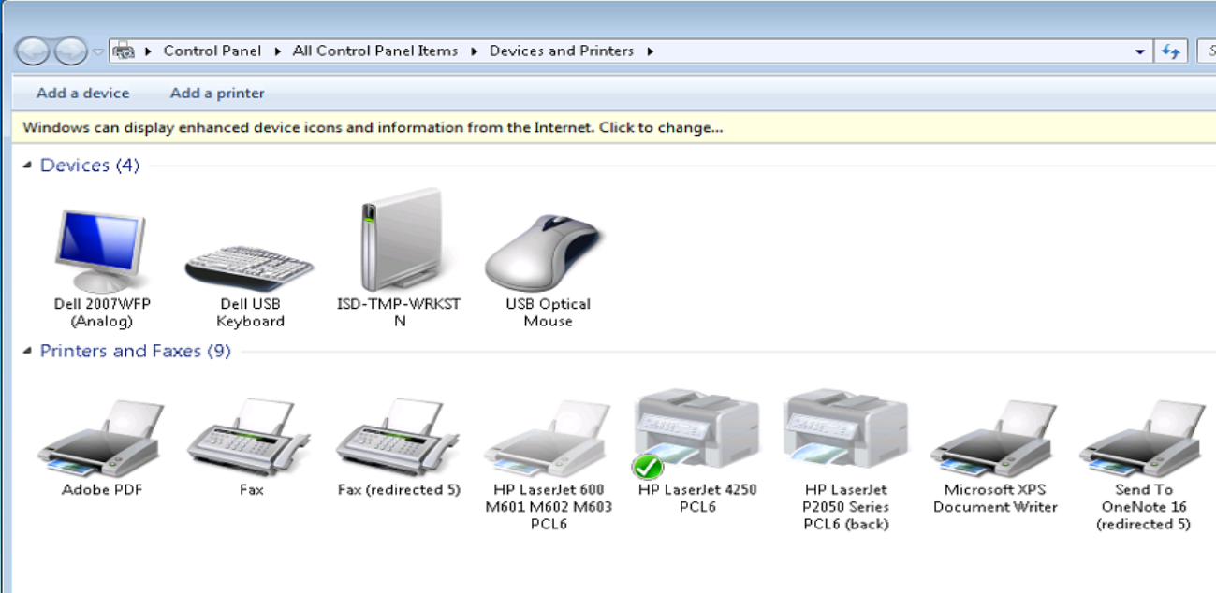
I shrunk it a bit but you can see what you need to. Right click on the image of the printer you need to update. It’ll look like below.
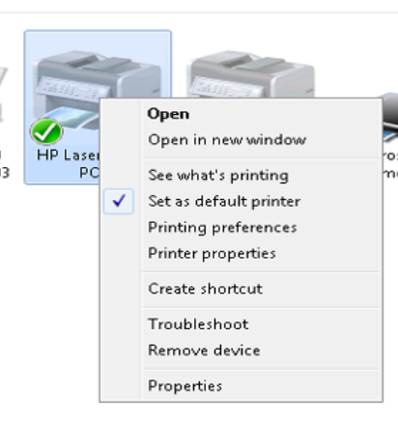

We’re going to click on “Printer properties” which brings up the next window.

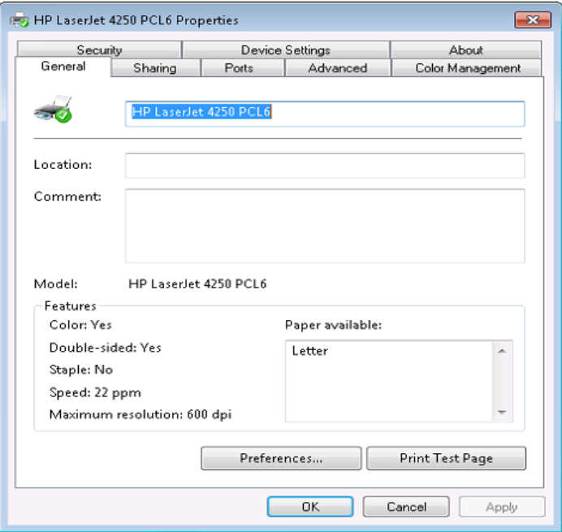

And now we’re going to click on the “Ports” tab, it’s two to the right of the General tab that is currently open.

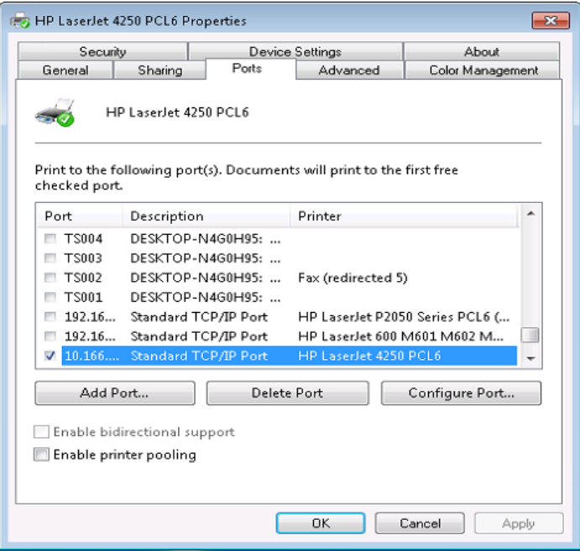

The printer is already highlighted so all we need to do is click on “Configure Port…” and you’ll see the next image.
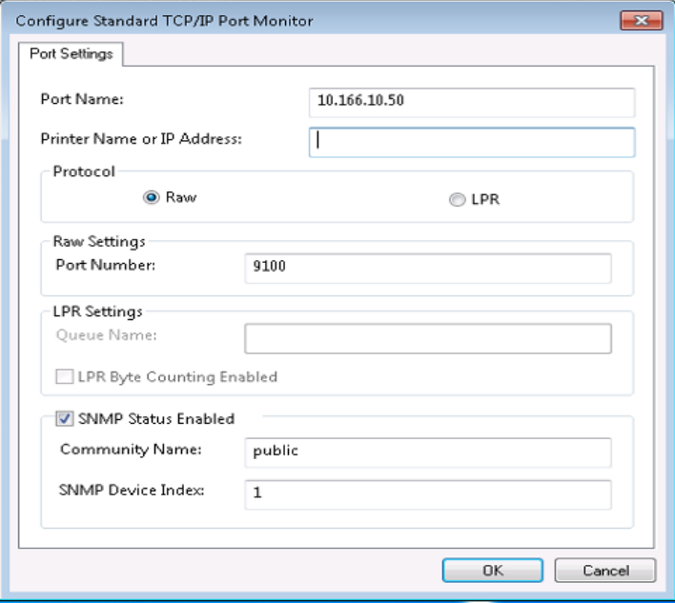

In order to cut down the number of images I’ve already deleted the 192.168. address that was in the “Printer Name or IP Address:” box. Do not concern yourself with the “Port Name:” box which is first, it’s an arbitrary name, you want the second box. Delete the contents and type in your 10.166. IP.

When the new IP is typed in then click “OK” and tell it to close then right click on the next printer and put in its new IP.

You’ll find the IP of the printer on the front of the printer as well as its name so just wander over to the printer you want to use and write its information down then put it in using the above instructions.

If you do the above then you won’t need new drivers installed. The ‘old’ ones will work fine.

You might be tempted to add printers you’ve never had access to. It might work, or it might not. Don’t bother putting in a help desk ticket if it doesn’t work though because we’re not installing drivers until the rest of the Press is up and running.

